**LAB EXERCISE 7**

**Aim: Selenium IDE**

Perform Automation testing using Selenium IDE for testing a web page.

* Test Blackboard Login Web Page using Selenium Web Driver

————————————————————————————————

**Sap ID:** 500082708

**Name:** Devyansh Samyal

**Batch:** DevOps B-1

**Test case for Blackboard login:**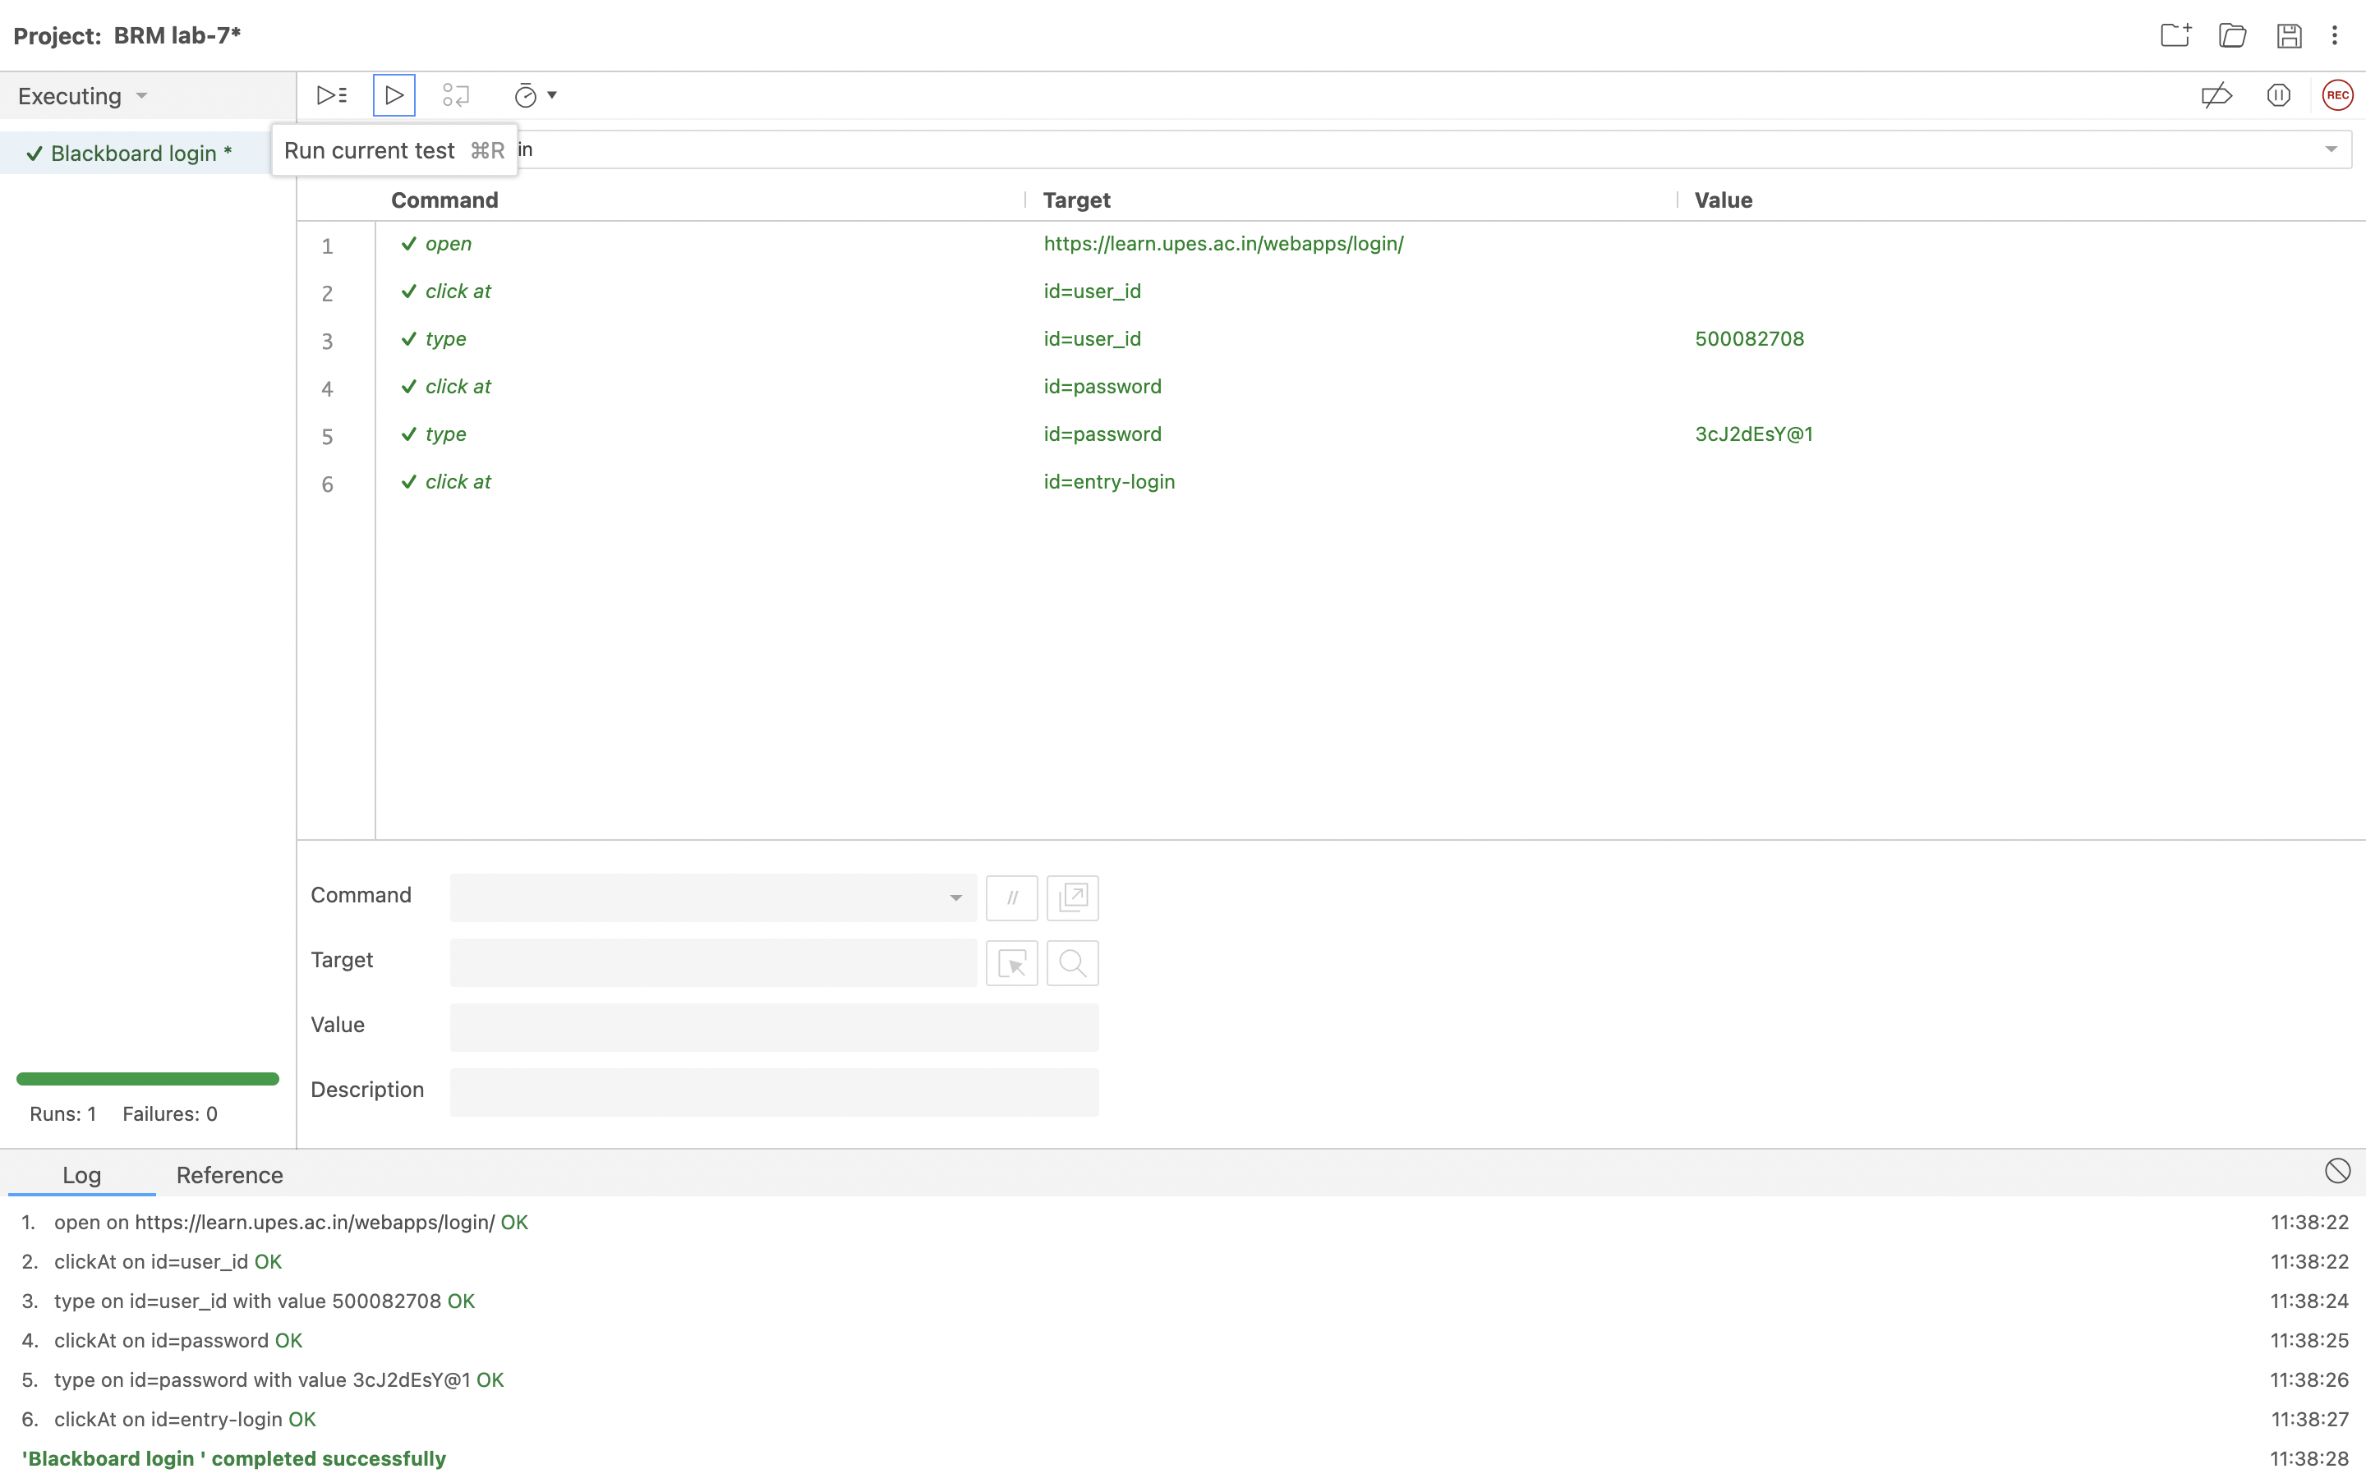

**Test case recording for Blackboard login:**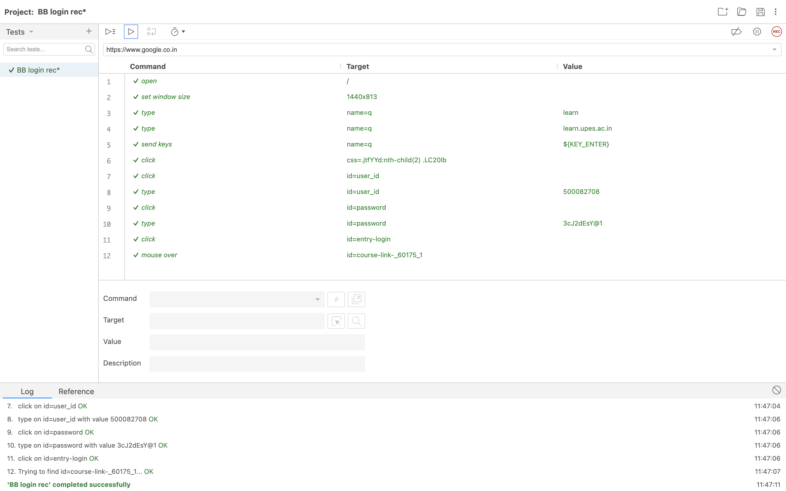

**Test case recording for Gmail login:**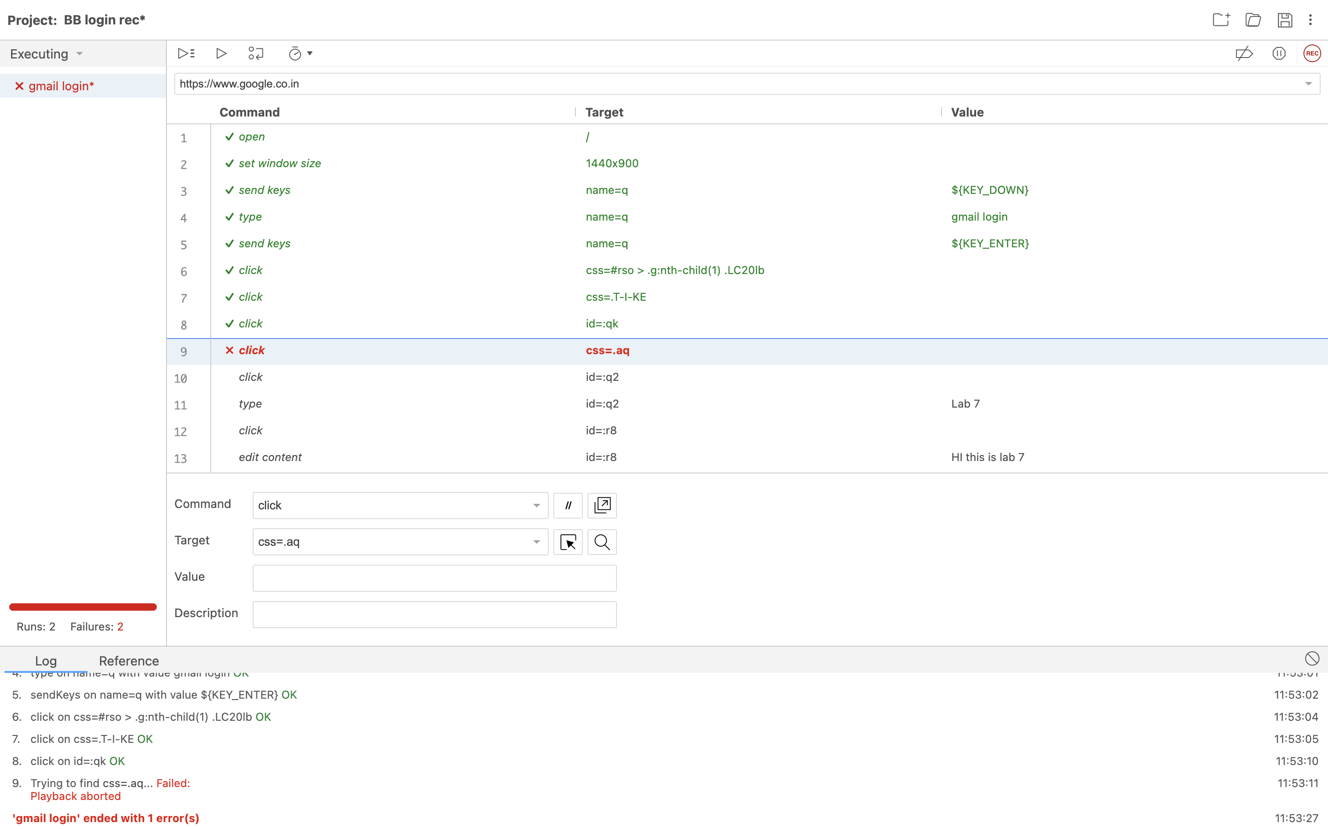

Given test was a failure due to a pop-up window within the google page.